|  |
| --- |
|  |
| Capstone Project Document |

**Vietnamese Medicinal Plants Network**

Report #6 – User Guide

|  |  |  |
| --- | --- | --- |
| **Vietnamese Medicinal Plants Network** | | |
| **Group Members** | Nguyễn Minh Tiến | SE02545 |
| Trần Bình Khánh | SE02764 |
| Nguyễn Hải Đăng | SE02992 |
| Hoàng Thị Quỳnh | SE02639 |
| **Supervisor** | Mr. Nguyễn Văn Sang | |
| **Project code** | VMN | |

**- Hanoi, 04/2016 -**

# SIGNATURE PAGE

AUTHOR: Nguyễn Hải Đăng 15/04/2016

Team member

REVIEWERS: Nguyễn Minh Tiến 16/04/2016

Project manager

APPROVAL: Nguyễn Văn Sang --/--/--16

Supervisor

Record of change

*A - Added M - Modified D – Deleted

|  |  |  |  |  |  |
| --- | --- | --- | --- | --- | --- |
| Effective Date | Changed Item | A,M,D | Change Description | Reason for Change | Rev. Number |
| 15/April/2016 | User guide | A | Add new |  | 1.0 |
|  |  |  |  |  |  |
|  |  |  |  |  |  |
|  |  |  |  |  |  |
|  |  |  |  |  |  |
|  |  |  |  |  |  |
|  |  |  |  |  |  |
|  |  |  |  |  |  |
|  |  |  |  |  |  |
|  |  |  |  |  |  |
|  |  |  |  |  |  |
|  |  |  |  |  |  |
|  |  |  |  |  |  |
|  |  |  |  |  |  |
|  |  |  |  |  |  |
|  |  |  |  |  |  |

Table of Contents

SIGNATURE PAGE 1

1 Introduction 3

2 USER GUIDELINES 3

2.1 Register 3

2.2 Login 4

2.3 Search 5

# Introduction

This user's manual has been developed to help users better understand the requirements that may apply to use this website by providing them simple step by step tutorials. This manual is intended to help make website's functions more accessible and their associated requirements more understandable to users.

# USER GUIDELINES

## Register

To register account on website, the users do the steps below:

Step 1: Open browser and enter to the address bar: <http://vmn.vnvalley.com>. Homepage is displayed.

Step 2: Click on Đăng ký button in header. Users will go to Register page.

Step 3: Enter information and click on Đăng ký button or Đăng ký nhà thuốc link.

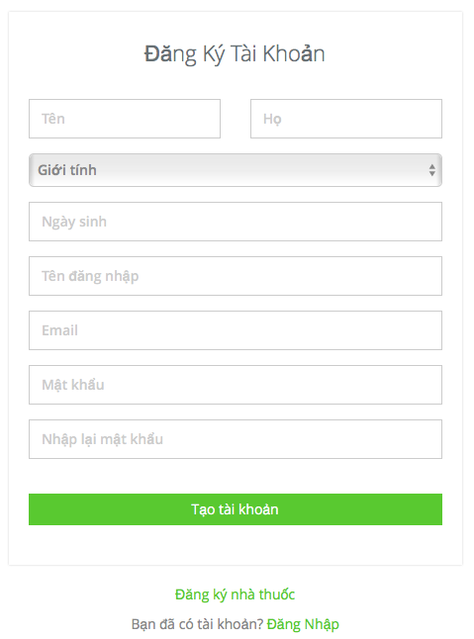

1. R**egister normal account screen**

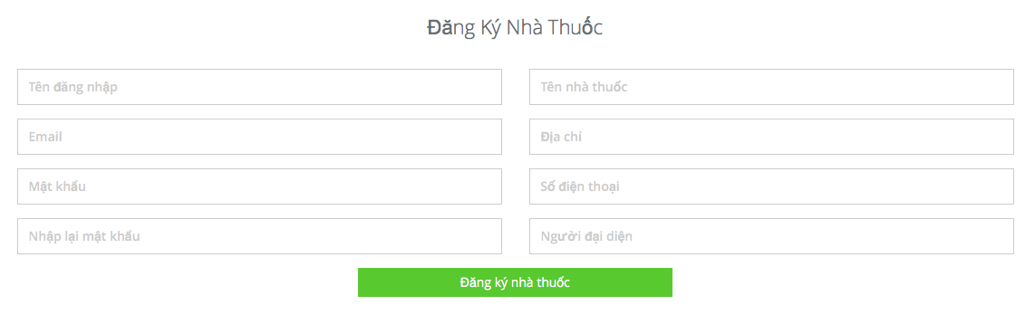

1. R**egister herbal medicine store account screen**

## Login

To login account on website, the users do the steps below:

Step 1: Open browser and enter to the address bar: <http://vmn.vnvalley.com> . Homepage is displayed.

Step 2: Click on Đăng nhập button in header. User will go to Login page.

Step 3: User login to VMN system:

Step 3.1: User enter username and password

Step 3.2: Click on Login button

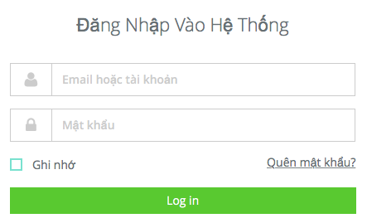

1. Login **page**

## Search

### Basic Search

To use search function on website, the users do the steps below:

Step 1: Open browser and enter to the address bar: <http://vmn.vnvalley.com> .

Step 2: In Home page, click on medicinal plant or remedy button in header.

Step 3: Input keywords and click on search icon or press enter.

Macintosh HD:Users:nguyenhaidang:Desktop:Screen Shot 2016-04-15 at 14.52.08.png

1. Basic search screen

Step3: Search result page is displayed.

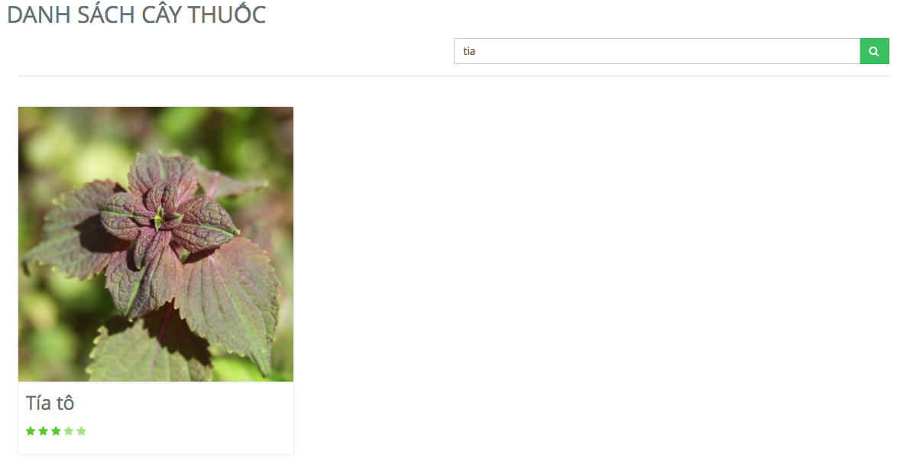

1. Search screen result

### Advance search medicinal plant

To use advance search medicinal plant function on website, the users do the steps below:

Step 1: Open browser and enter to the address bar: <http://vmn.vnvalley.com> .

Step 2: In Home page, click on medicinal plant button in header.

Step 3: Click on advance search medicinal plant button.

Step 4: Input keywords and click on search button.

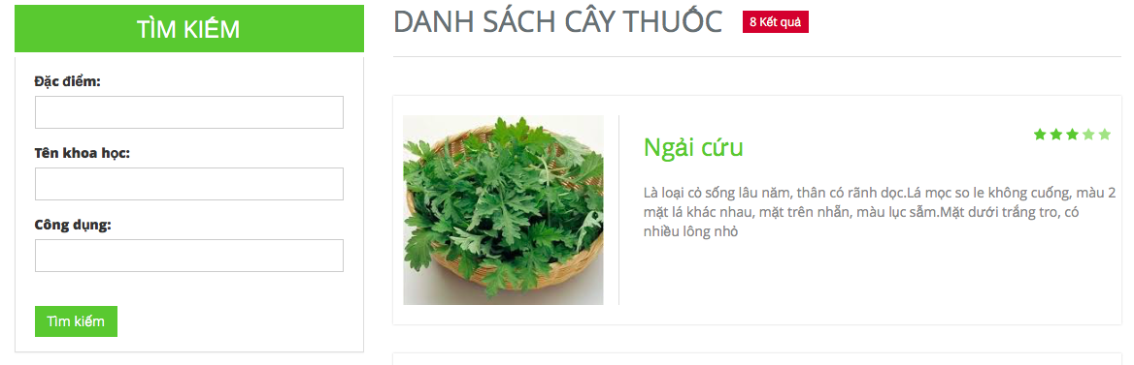

1. Advance search medicinal plant

### Advance search remedy

To use advance search remedy function on website, the users do the steps below:

Step 1: Open browser and enter to the address bar: <http://vmn.vnvalley.com> .

Step 2: In Home page, click on remedy button in header.

Step 3: Click on advance search remedy button.

Step 3: Input keywords and click on search button.

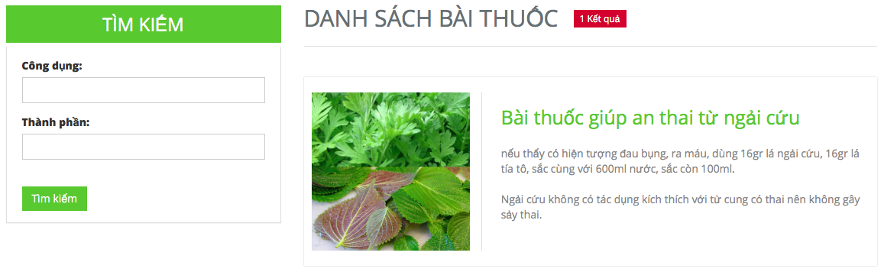

1. Advance search remedy

## Medicinal Plants

Click button Medicinal Plants in header to go to medicinal plants page.

To use contribute medicinal plants article or advance search medicinal plants function on website, the users do step below:

Step 1: Open browser and enter to the address bar: <http://vmn.vnvalley.com> .

Step 2: In home page click on button medicinal plants in header.

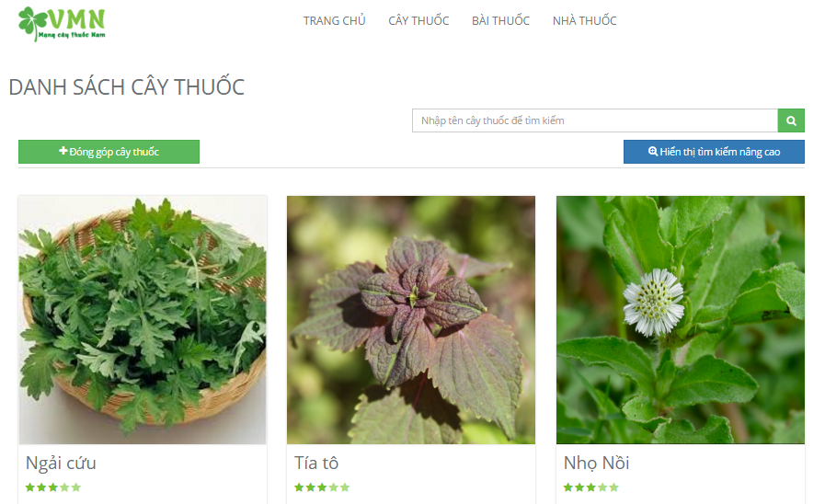

1. Medicinal plants

## Remedy

Click button Medicinal Plants in header to go to remedy page

To use contribute remedy article or advance search remedy function on website, the users do step below:

Step 1: Open browser and enter to the address bar: <http://vmn.vnvalley.com> .

Step 2: In home page click on button remedy in header.

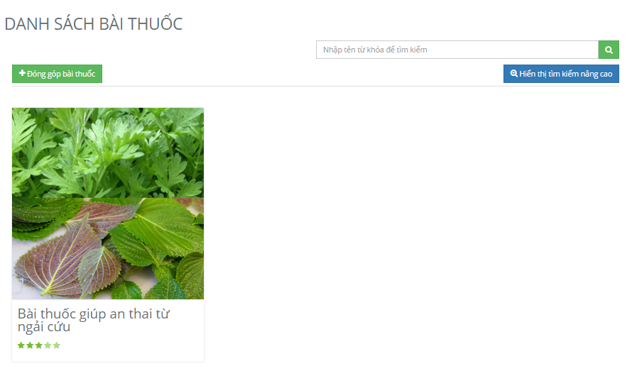

1. Remedy

## Herbal medicine store

To use herbal medicine store search function on the website, the users do the steps below:

Step 1: Open browser and enter to the address bar: <http://vmn.vnvalley.com> .

Step 2: Click on login button in header and login vmn system successful.

Step 3: Click on herbal medicine store button in header.

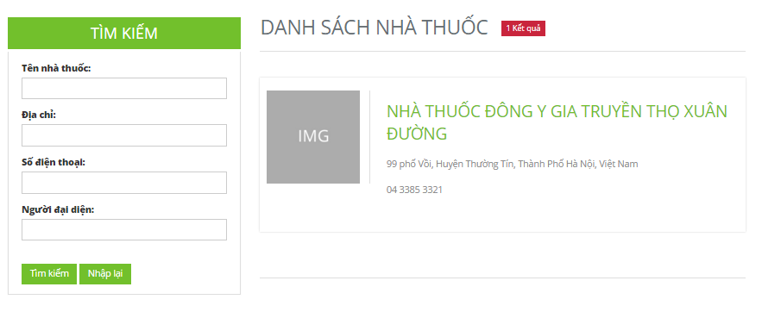

1. Herbal medicine store

### Herbal medicine store detail

Click on a herbal medicine store in herbal medicine store page to go to herbal medicine store detail.

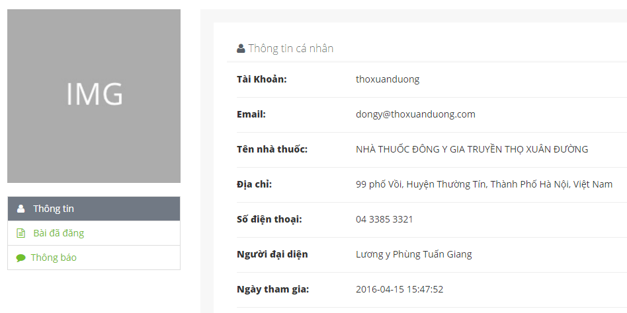

1. Herbal medicine store detail

## Contribute new article

### Contribute new medicinal plant

To use contribute new medicinal plant function on the website, the users do the steps below:

Step 1: Open browser and enter to the address bar: <http://vmn.vnvalley.com> .

Step 2: Click on login button in header and login vmn system successful.

Step 3: Click on medicinal plant button in header.

Step 4: Click on Contribute new medicinal plant button.

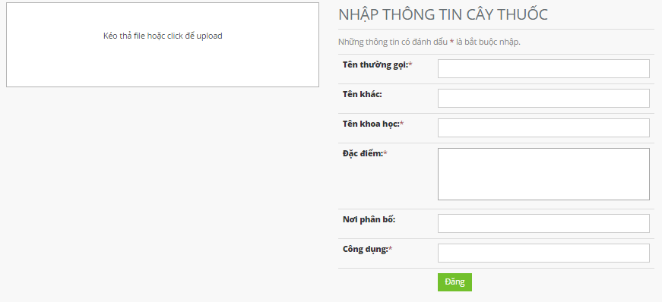

1. Contribute new medicinal plant

### Contribute new remedy

To use contribute new remedy function on the website, the users do the steps below:

Step 1: Open browser and enter to the address bar: <http://vmn.vnvalley.com> .

Step 2: Click on login button in header and login vmn system successful.

Step 3: Click on remedy button in header.

Step 4: Click on Contribute new remedy button.

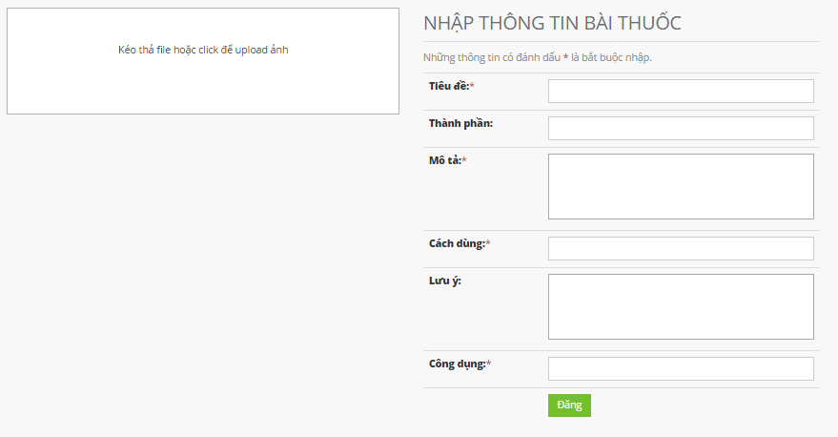

1. Contribute new remedy

## Edit article

### Edit medicinal plants article

To use edit medicinal plants article function on the website, the users do the steps below:

Step 1: Open browser and enter to the address bar: <http://vmn.vnvalley.com> .

Step 2: Click on login button in header and login vmn system successful.

Step 3: Click on medicinal plant button in header.

Step 4: Click on a medicinal plant.

Step 5: Click on edit button. (Edit button is displayed only if the user contributed this article).

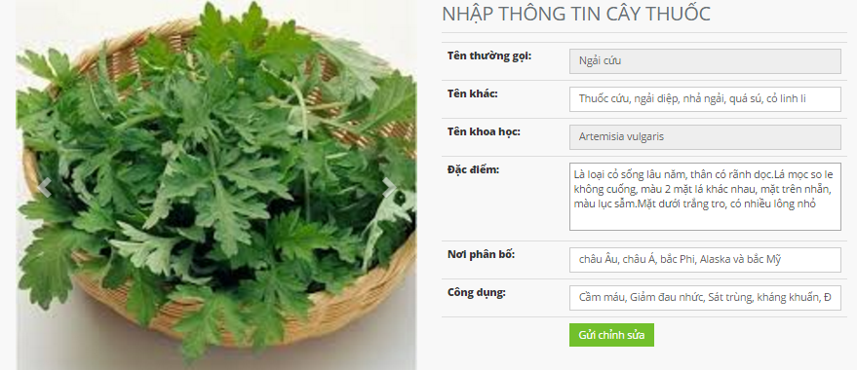

1. Edit medicinal plants article

### Edit remedy article

To use edit remedy article function on the website, the users do the steps below:

Step 1: Open browser and enter to the address bar: <http://vmn.vnvalley.com> .

Step 2: Click on login button in header and login vmn system successful.

Step 3: Click on remedy button in header.

Step 4: Click on a remedy.

Step 5: Click on edit button. (Edit button is displayed only if the user contributed this article).

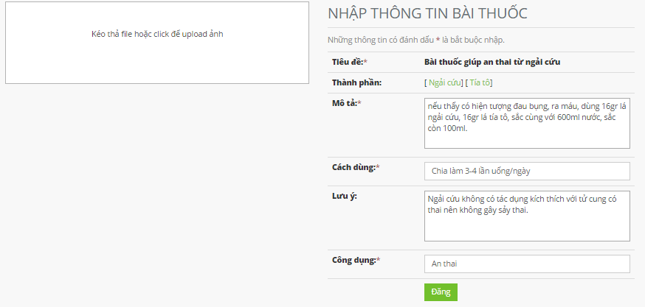

1. Edit remedy article

## Article detail

### Medicinal plant detail

To use medicinal plants detail function on the website, the users do the steps below:

Step 1: Open browser and enter to the address bar: <http://vmn.vnvalley.com> .

Step 2: Click on login button in header and login vmn system successful.

Step 3: Click on medicinal plant button in header.

Step 4: Click on a medicinal plant.

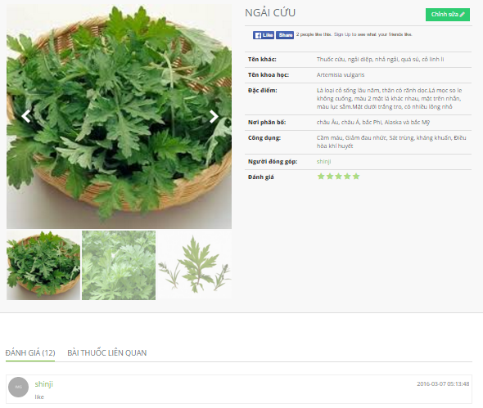

1. Medicinal plant detail

### Remedy detail

To use remedy detail function on the website, the users do the steps below:

Step 1: Open browser and enter to the address bar: <http://vmn.vnvalley.com> .

Step 2: Click on login button in header and login vmn system successful.

Step 3: Click on remedy button in header.

Step 4: Click on a remedy of remedy page.

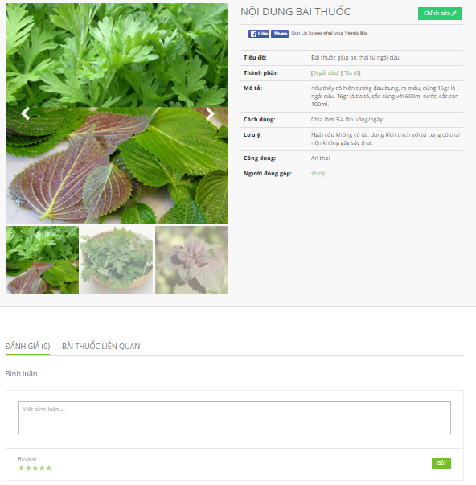

1. Remedy detail

## Report

To use report function on the website, the users do the steps below:

Step 1: Open browser and enter to the address bar: <http://vmn.vnvalley.com> .

Step 2: Click on login button in header and login vmn system successful.

Step 3: Click on medicinal plant or remedy button in header.

Step 4: Click on a medicinal plant or a remedy.

Step 5: Click on report button (report button is displayed only if this article is not the user’s article).



1. Report

## Menu account

### User profile

To use view user profile function, the users can do one of 2 ways below:

Way 1: User do not login vmn system.

Step 1: Open browser and enter to the address bar: <http://vmn.vnvalley.com> .

Step 2: Click on medicinal plant or remedy button in header.

Step 3: Click on a medicinal plant or a remedy article.

Step 4: Click on an author link of this article.

Way 2: User login vmn system successful.

Step 1: Open browser and enter to the address bar: <http://vmn.vnvalley.com> .

Step 2: Click on user profile link in header.

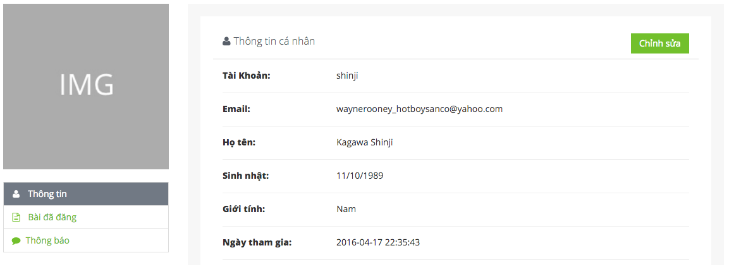

1. User profile

### Change profile

To use change profile function, the users do the steps below:

Step 1: Open browser and enter to the address bar: <http://vmn.vnvalley.com> .

Step 2: Click on user profile link in header.

Step 3: Click on edit button on user profile page.

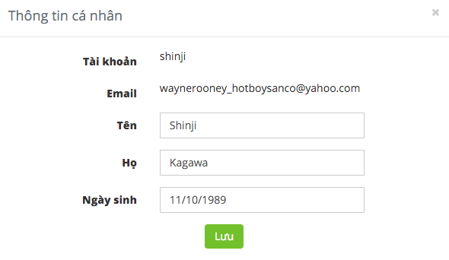

1. Change profile

### Message content

To use message content function, the users do the steps below:

Step 1: Open browser and enter to the address bar: <http://vmn.vnvalley.com> .

Step 2: Click on user profile link in header.

Step 3: Click on message button.



1. Message content

### Contributed articles

To use contributed articles function, the users do the steps below:

Step 1: Open browser and enter to the address bar: <http://vmn.vnvalley.com> .

Step 2: Click on user profile link in header. Users will go to user profile page.

Step 3: Click on contributed articles button.

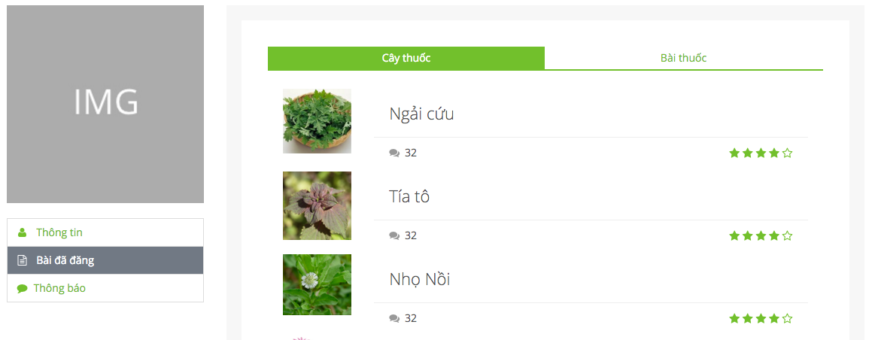

1. Contributed articles

## Admin

### Dashboard of admin

To view dashboard of admin, the users do the steps below:

Step 1: Open browser and enter to the address bar: <http://admin.vmn.vnvalley.com/managementLogin> .

Step 2: Write username is “iamadmin” and password “tiennm”.

Step 3: Click login button.

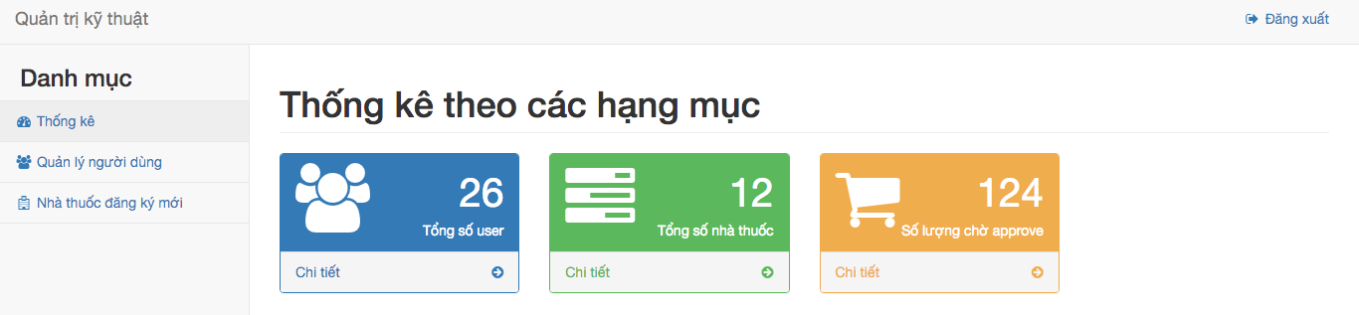

1. Dashboard of admin

### Member management

To use member management function, the users do the steps below:

Step 1: Open browser and enter to the address bar: <http://admin.vmn.vnvalley.com/managementLogin> .

Step 2: Login successful.

Step 3: Click on member management button.

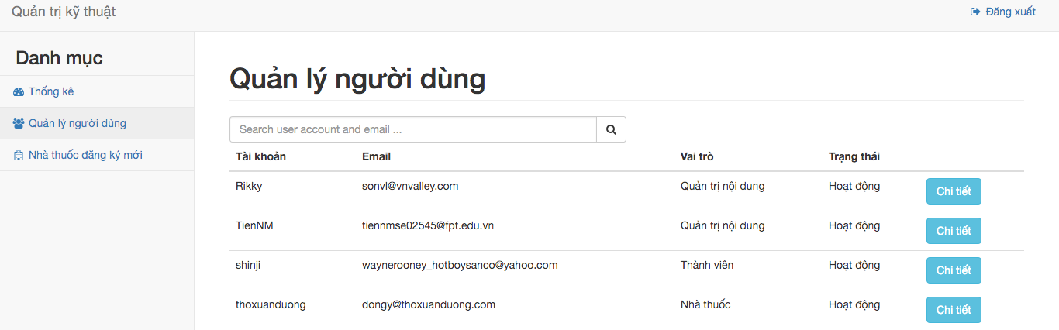

1. Member management

### Member detail

To use member management function, the users do the steps below:

Step 1: Open browser and enter to the address bar: <http://admin.vmn.vnvalley.com/managementLogin> .

Step 2: Login successful.

Step 3: Click on member management button.

Step 4: Click on detail button of an account.

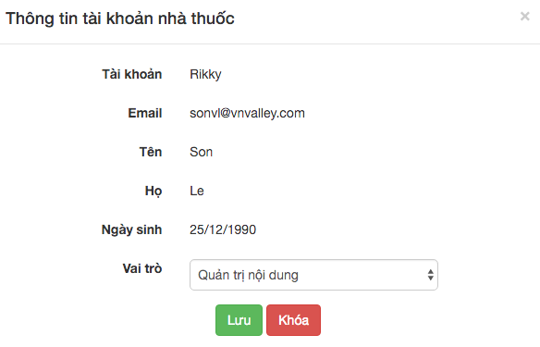

1. Member detail

### Herbal medicine store management

To use member management function, the users do the steps below:

Step 1: Open browser and enter to the address bar: <http://admin.vmn.vnvalley.com/managementLogin> .

Step 2: Login successful.

Step 3: Click on herbal medicine store management button.

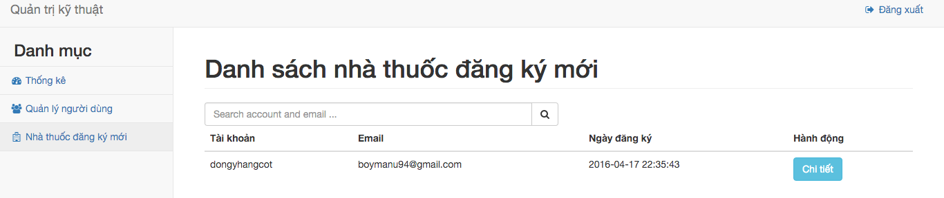

1. Herbal medicine store management

### Herbal medicine store detail

To use member management function, the users do the steps below:

Step 1: Open browser and enter to the address bar: <http://admin.vmn.vnvalley.com/managementLogin> .

Step 2: Login successful.

Step 3: Click on herbal medicine store management button.

Step 4: Click on detail button of an account.

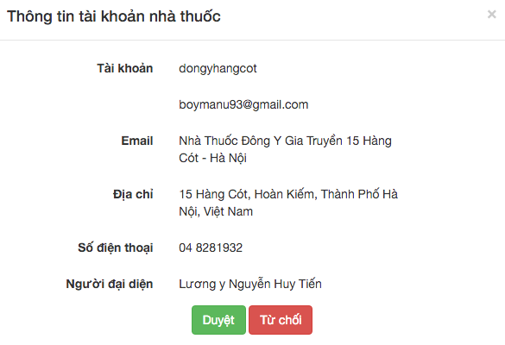

1. Herbal medicine store detail

## Mod

### Dashboard of mod

To view dashboard of admin, the users do the steps below:

Step 1: Open browser and enter to the address bar: <http://admin.vmn.vnvalley.com/managementLogin> .

Step 2: Write username is “tiennm” and password “tiennm”.

Step 3: Click login button.

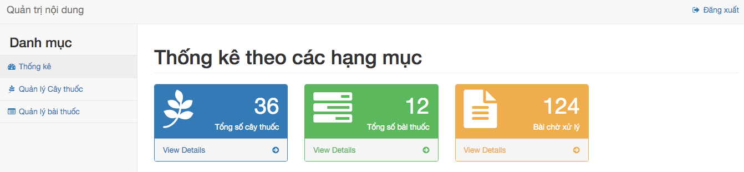

1. Dashboard of mod

### New medicinal plants management

To use member management function, the users do the steps below:

Step 1: Open browser and enter to the address bar: <http://admin.vmn.vnvalley.com/managementLogin> .

Step 2: Login successful.

Step 3: Click on medicinal plants management button.

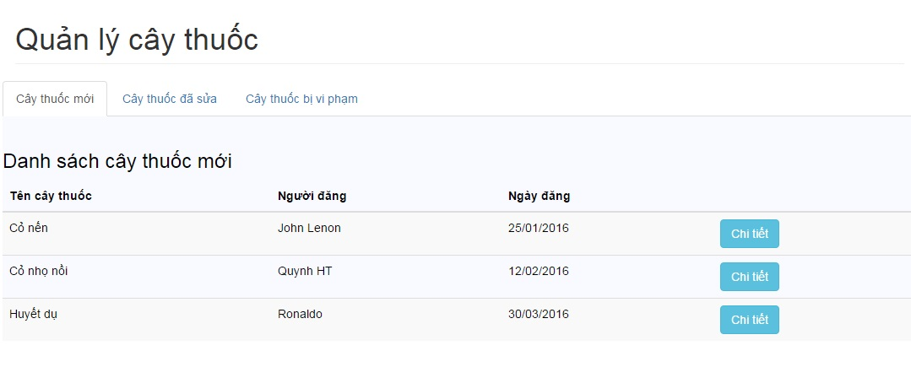

1. New medicinal plants management

### New medicinal plant detail

To use member management function, the users do the steps below:

Step 1: Open browser and enter to the address bar: <http://admin.vmn.vnvalley.com/managementLogin> .

Step 2: Login successful.

Step 3: Click on medicinal plants management button.

Step 4: Click on button detail.

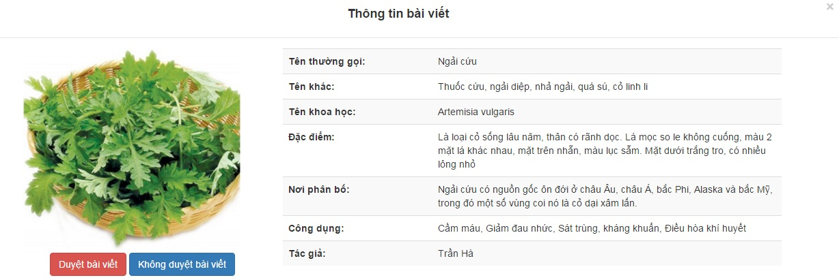

1. New medicinal plant detail

### Edited medicinal plants management

To use member management function, the users do the steps below:

Step 1: Open browser and enter to the address bar: <http://admin.vmn.vnvalley.com/managementLogin> .

Step 2: Login successful.

Step 3: Click on medicinal plants management button.

Step 4: Click on edited medicinal plants button.

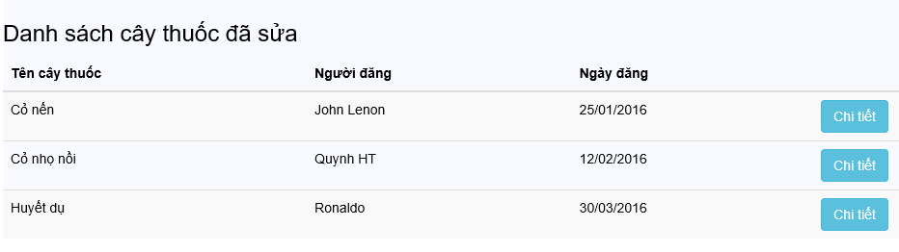

1. Edited medicinal plants management

### Edited medicinal plant detail

To use member management function, the users do the steps below:

Step 1: Open browser and enter to the address bar: <http://admin.vmn.vnvalley.com/managementLogin> .

Step 2: Login successful.

Step 3: Click on medicinal plants management button.

Step 4: Click on edited medicinal plants button.   
Step 5: Click on detail button.



1. Edited medicinal plant detail

### Reported medicinal plants management

To use member management function, the users do the steps below:

Step 1: Open browser and enter to the address bar: <http://admin.vmn.vnvalley.com/managementLogin> .

Step 2: Login successful.

Step 3: Click on medicinal plants management button.

Step 4: Click on reported medicinal plants button.

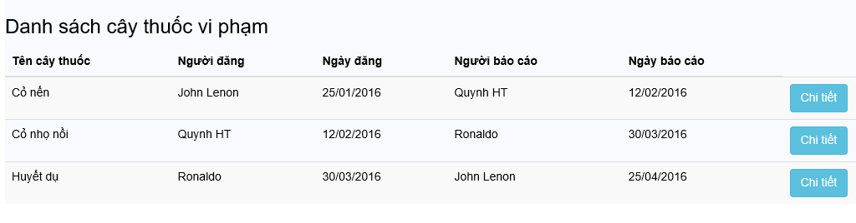

1. Reported medicinal plants management

### Reported medicinal plant detail

To use member management function, the users do the steps below:

Step 1: Open browser and enter to the address bar: <http://admin.vmn.vnvalley.com/managementLogin> .

Step 2: Login successful.

Step 3: Click on medicinal plants management button.

Step 4: Click on reported medicinal plants button.

Step 5: Click on detail.

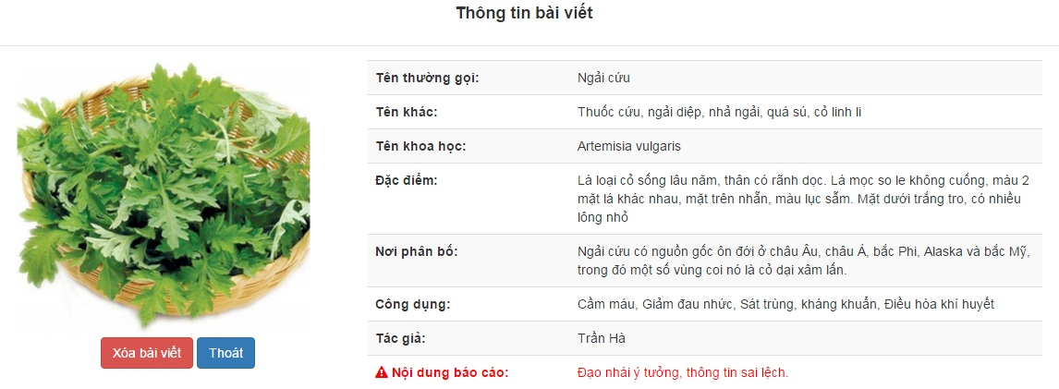

1. Reported medicinal plant detail

### New remedy management

To use member management function, the users do the steps below:

Step 1: Open browser and enter to the address bar: <http://admin.vmn.vnvalley.com/managementLogin> .

Step 2: Login successful.

Step 3: Click on remedy management button.

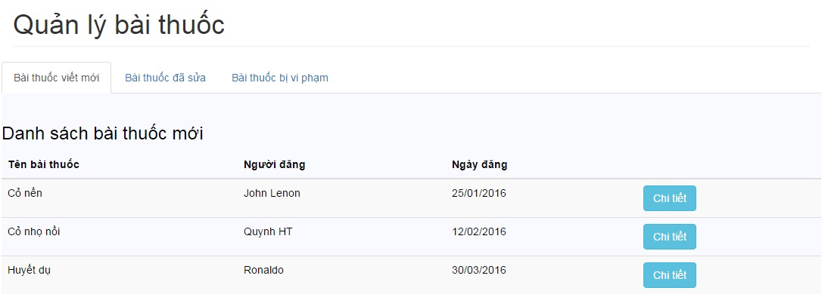

1. New remedy management

### New remedy detail

To use member management function, the users do the steps below:

Step 1: Open browser and enter to the address bar: <http://admin.vmn.vnvalley.com/managementLogin> .

Step 2: Login successful.

Step 3: Click on remedy management button.

Step 4: Click on detail button.

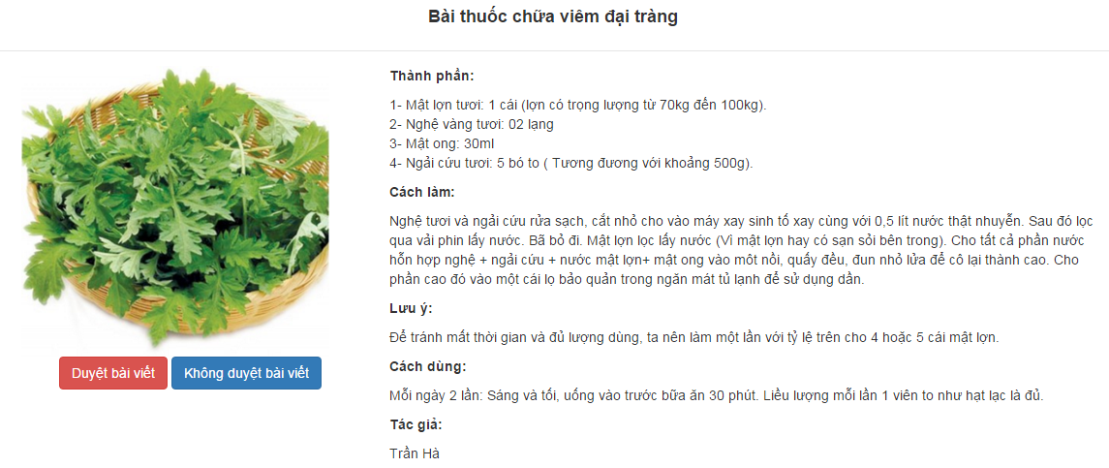

1. New remedy detail

### Edited remedy management

To use member management function, the users do the steps below:

Step 1: Open browser and enter to the address bar: <http://admin.vmn.vnvalley.com/managementLogin> .

Step 2: Login successful. Users will go to mod page.

Step 3: Click on remedy management button.

Step 4: Click on edited remedy button.

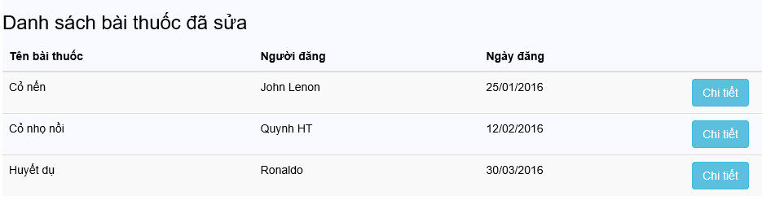

1. Edited remedy management

### Edited remedy detail

To use member management function, the users do the steps below:

Step 1: Open browser and enter to the address bar: <http://admin.vmn.vnvalley.com/managementLogin> .

Step 2: Login successful.

Step 3: Click on remedy management button.

Step 4: Click on edited remedy button.

Step 5: Click on detail button.



1. Edited remedy detail

### Reported remedy management

To use member management function, the users do the steps below:

Step 1: Open browser and enter to the address bar: <http://admin.vmn.vnvalley.com/managementLogin> .

Step 2: Login successful.

Step 3: Click on remedy management button.

Step 4: Click on reported remedy button.



1. Reported remedy management

### Reported remedy detail

To use member management function, the users do the steps below:

Step 1: Open browser and enter to the address bar: <http://admin.vmn.vnvalley.com/managementLogin> .

Step 2: Login successful.

Step 3: Click on remedy management button.

Step 4: Click on reported remedy button.

Step 5: Click on detail button.

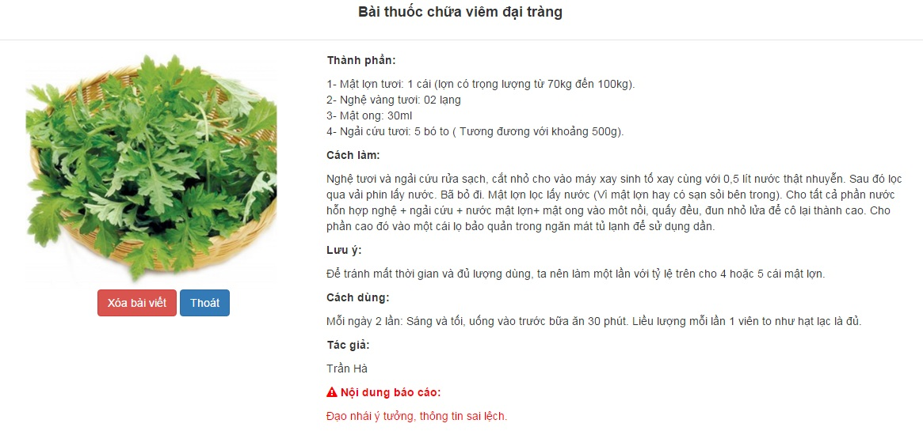

1. Reported remedy detail